**ETL PIPELINE PROJECT**

**Brief description of the project**

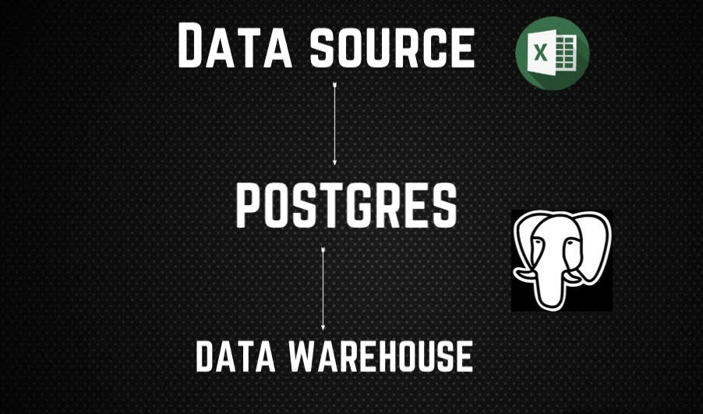

**This project is about a simple ETL pipeline created without any form of orchestration such as AIRFLOW OR DAGSTER nor any form of automation, CSV table is extracted using pandas and uploaded in POSTGRES using pandas.**

**CSV data is then transformed in Postgres using different SQL functions and loaded into a data warehouse specifically created for this CSV. The database tables are relational having primary and foreign keys relating to each other hereby.**

**On the final part of the project some really basic analysis is done and get some insights about the database and the visualization is done in excel.**